* To get getEmployee details from addEmployee details:
* We can do this using custom properties also.
* To pass the name from AddEmployee write the xpath. Eg:

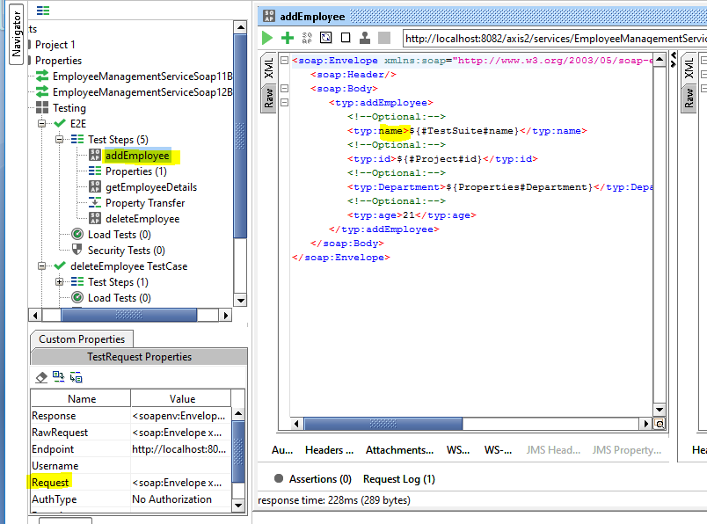

${addEmployee#Request#//typ:addEmployee/typ:name/text()}

